

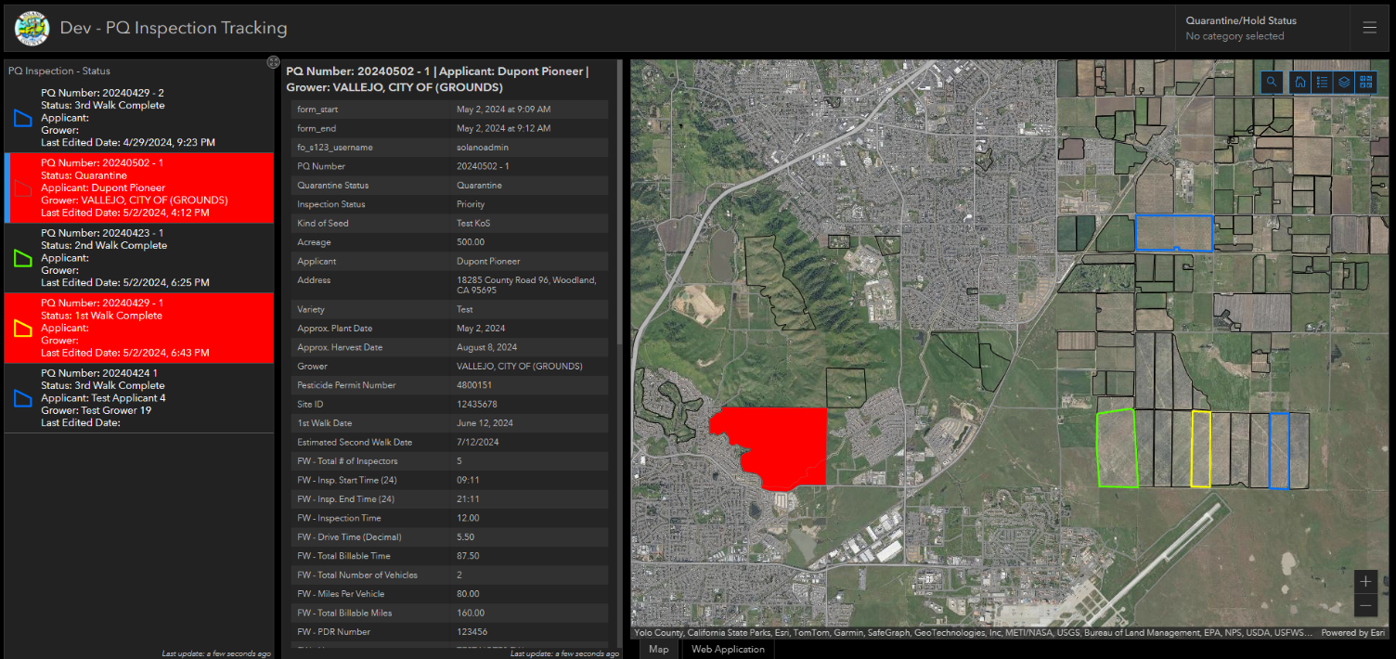
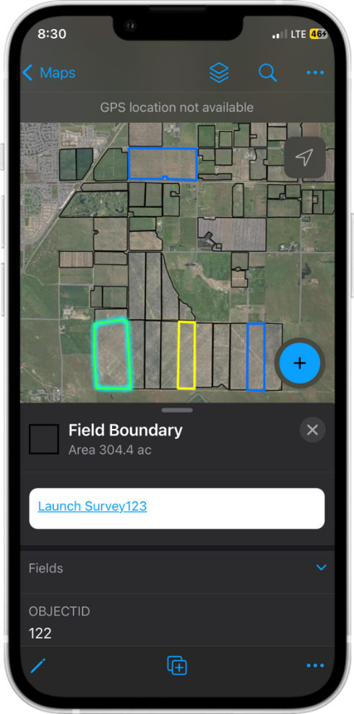
USER GUIDE DOCUMENTATION

PQ Inspection Tracking (DEV)

Prepared for: Solano County, California
Department of Information Technology

Prepared by: KCI Technologies, Inc.

Table of Contents
Table of Contents 2
Document Control 3
APPLICATION URLs 4
QUICK START GUIDE 5
SOLUTION DETAILS & USER GUIDE 8
Map / App Layers 8
Dashboard 9
Web / Desktop Application 10
Field Maps 11
Survey123 11

Document Control
Version | Date | Purpose / Action | Author
1.0 | 5/3/2024 | Document created for DEV Version | Andrew Blowers (KCI)

APPLICATION URLs
The following URLs provide access to the Development PQ Inspection Tracking solution.
- Portal Group
  - Dev - PQ Inspection Tracking
    - https://solanocountygis.com/portal/home/group.html?id=0669c9fbb8164b75b84c70d0ba131e6d#overview
- Web / Desktop Application
  - Dev – PQ Inspection Tracking
    - https://solanocountygis.com/portal/apps/webappviewer/index.html?id=e75b84f4a4f0493b862cefa44e1e6f88
      - The Web / Desktop Application is embedded in the dashboard for convenience
- Dashboard
  - Dev – PQ Inspection Tracking
    - https://solanocountygis.com/portal/apps/dashboards/d05c2171a8964c189edeb0d6861e07d2
- Survey123
  - Form - https://solanocountygis.com/portal/home/item.html?id=dfa40edadf35427bb6dc3ccf4c5522b0
  - CSV Files
    - Applicant_address - https://solanocountygis.com/portal/home/item.html?id=cc6d2bfbae8a429d8bcee68d713acffd
    - Grower_pesticide_perm_num - https://solanocountygis.com/portal/home/item.html?id=99f2ef7d9a454d20b58dc793cc3a6487
- Field Maps and Survey123
  - Users can launch a Survey123 form from Field Maps, Dashboard, or Web / Desktop Application. Forms started from Field Maps must be launched via the URL on the Field Boundaries feature layer. Subsequent edits to forms must be completed via the Inbox directly in the Survey123 desktop or mobile field app.

QUICK START GUIDE
The following provides high-level guidance for using the IST solution
I want to… | Solution Feature
Start a new PQ Inspection Tracking Record from a desktop/laptop | Use the Dashboard or Web / Desktop Application (web / desktop app can be access directly or as embedded app in the Dashboard). Alternatively, use the Field Maps mobile app.  All PQ Inspection Tracking records are created via field boundary polygons. To start a PQ record, navigate to and select a field boundary polygon, then select the Launch Survey123 hyperlink from the popup.  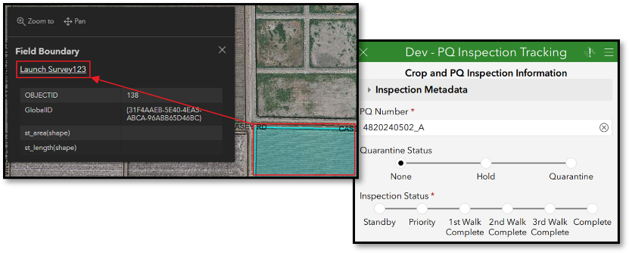  *Screenshots above are from the Dashboard Map
Update the PQ Inspection Tracking Survey123 Form’s Inbox | This solution utilizes the inbox to facilitate the lifecycle of a PQ Inspection Tracking record and consolidate all values into one table record. It is important that the Inbox remains up to date to avoid overwriting values should the record have been edited by another user. If records need to be edited in an offline fashion, refresh the Inbox before disconnecting from a cellular / Wi-Fi network.  Open the Survey123 application on the desktop or mobile device. Open the “PQ Inspection Tracking” form from the applications home screen. Select the “Inbox” option at the bottom of the screen. Use the refresh button or pull down from the top of the records to perform the refresh. Note that the Inbox does not include records with an inspection status of “Complete.”
View or Modify an Existing PQ Inspection Tracking Record | Use the desktop or mobile version of the Survey123 Application.  Open the “Dev – PQ Inspection Tracking Form” and refresh the Inbox.  Search for the corresponding PQ Number, Grower, Applicant, etc., or scroll/swipe through the records and select the desired record.  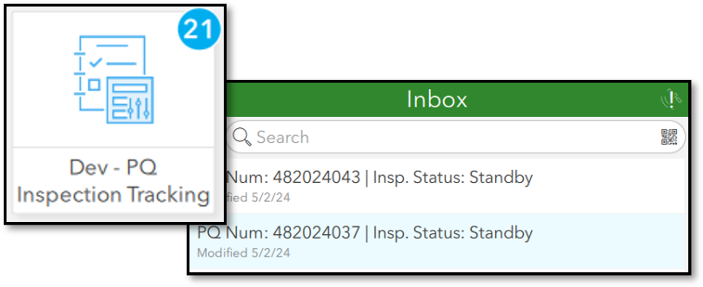  Modify the form as necessary navigate to the last page (5 of 5) and select the checkmark. Choose “Send Now” if the mobile device has a cellular / Wi-Fi connection or “Save in Outbox” if disconnected from a network.
View Active PQ Inspection Tracking Records | Use the Dashboard to view the status of fields and PQ Inspections.  The left-hand list shows information for both the field (Quarantine Status) and the PQ Inspection (Standby, 1st Walk Complete, 3rd Walk Complete, etc.). Selecting one or more fields in this list will filter the second list.  The second list displays all fields from the PQ Inspection Tracking Survey123 record and attachments.  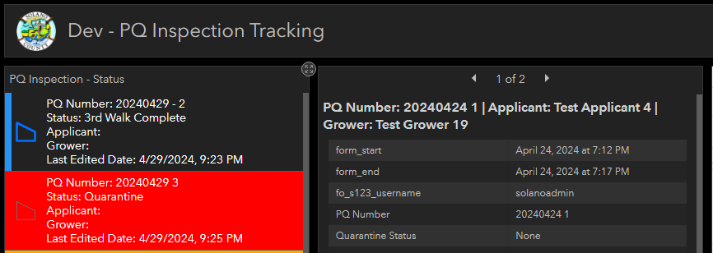
Export All PQ Inspection Tracking Records | Use the Web / Desktop Application embedded in the Dashboard or access it directly.  The Web / Desktop Application is included in the dashboard for convenience and simplifies desktop workflows. Accessing the application directly in a browser is identical.  Select the “Web Application” tab below the map pane and select the “Attribute Table” widget within the application. The widget will display the records for features included in the widget.  Switch the attribute table to “All Records” to display all PQ Inspection Tracking records for the calendar year. Select the “Options” button and select “Export all to CSV.” The CSV will download via the browser.  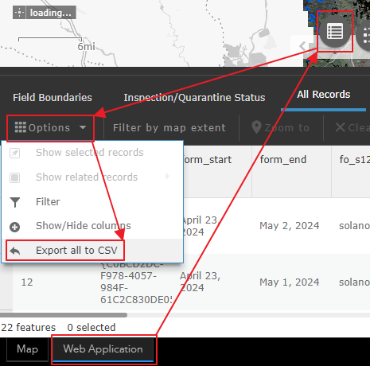
Update Applicant / Address and Grower / Pesticide Permit Number CSV files. | The PQ Inspection Tracking Survey123 form utilizes “linked content” CSV files to control the values available in the Applicant / Address and Grower / Pesticide Permit Number choice pairs. The external lists facilitate easier updates and quicker loading times.  Use the Portal Item linked in the APPLICATION URLs section of the document to navigate to the item. Modify a version of the CSV locally or download one from the Portal. Use the “Update” option to push a new CSV file version to the Portal and overwrite the existing one.  Survey123 should automatically download the latest version. However, users must open the form directly in the Survey123 application for this to occur. The lists will not update automatically if the application is launched via the hyperlink in the Dashboard, Web / Desktop Application, or Field Maps.

SOLUTION DETAILS & USER GUIDE
The following section details the different components of the solution and the use cases for each.

Map / App Layers
The following layers are used throughout the solution. As shown below, two layers have been set up with specific definitions to quickly view PQ records that meet specific criteria on a map and/or table. Note that the layer order will vary between the Web / Desktop App and the Dashboard / Field Maps mobile app.
Below: Screenshot of Web / Desktop App table of contents and description of each layer
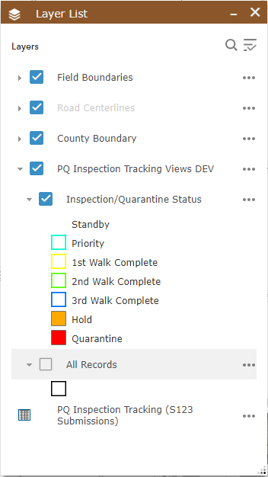

Group / Layer Name | Description
Field Boundaries | Reference feature layer of all relevant fields for PQ Inspections. While a reference feature, users can add new fields via the Edit widget in the Web / Desktop Application or Field Maps Mobile Application.
Road Centerlines | Reference layer of County road centerlines maintained by various County resources.
County Boundary | Standard Solano County boundary feature layer
PQ Inspection Tracking Views (Layer Group) | Note that all layers in this group are dynamic and are updated when changes occur to individual PQ records.
Inspection/Quarantine Status | A view aggregating the PQ Inspection Tracking records related to field boundary features and grouping them by the inspection and quarantine status. The layer's purpose is to consolidate both statuses into a single field. The layer is configured to filter out records with a “Complete” status and those with a “walk” date or created date outside of the current calendar year.  - Standby  - Priority  - 1st Walk Complete  - 2nd Walk Complete  - 3rd Walk Complete  - Hold  - Quarantine
All Records | Layer that shows all PQ records. PQ records are displayed with the field boundary geometry they are related to. Expect stacked geometry for these layers if more than one PQ record exists for a field – each PQ record is symbolized with its related geometry.
PQ Inspection Tracking (S123 Submissions) (Table) | This is the database table to which the Survey123 submissions are written. The table facilitates the views and display of records in the dashboard. It is not filtered by any date parameters and will include all submissions from the PQ Inspection Tracking form.

Dashboard
- Use Cases
- View field boundaries based on the “Status” and high-level information about all active/quarantined fields.
- View complete records from the Surevy123 submissions.
- View attachments from Survey123 or those added from the web / desktop application.
- Select field boundaries to launch/initiate a PQ Inspection Tracking record via the Survey123 desktop application.
- View / User the web / desktop application via the tab below the map pane.
- Features
- Left side of the dashboard – PQ Inspection / Field status list and individual PQ records
  - The “Status” list allows for the selection of multiple records and controls the individual record list to the right.
- Right side of the dashboard – map / tools, web / desktop application (tab)
  - The “Status” list is controlled by the map's extent.
  - Selecting a field boundary polygon from the map displays the feature’s pop-up, which contains the Survey123 hyperlink used to launch a new form in the desktop application.
- Workflows – Dashboard
- View “Status” and Other Details
    - Select one or more records in the Status list on the far left-hand side of the dashboard.
    - The list to the right will display the complete Survey123 record for the related to the field boundary(ies) selected and any attachments.
  - Launch a new PQ Inspection Tracking Record from the Map
    - Zoom to the desired field boundary or search for an address on the map.
    - Select the Field Boundary polygon to display the popup.
    - Select the “Launch Survey123” hyperlink to launch the Survey123 desktop application and start the record.

Web / Desktop Application
  - Use Cases
    - View the field boundaries and “Status” view layers
    - Launch Survey123 inspections via the popup on a field boundary polygon
    - Export records from all available features or tables using the Attribute Table widget
  - Features
    - Search bar
- Search by address, PQ Number, Applicant or Grower
    - Widget Launch Bar
      - Attribute Table – allows users to view and export the attribute table for all relevant features in the layer list.
      - Legend – displays the visible layers in the map.
      - Layer List – allows the user to toggle layers on/off, change order, adjust transparency, and other functions.
      - Basemap Gallery – allows users to change the basemap utilizing the organization's complete base map gallery
      - Bookmarks – allows users to store map bookmarks in the application.
        - Note that these bookmarks will not carry over to the Field Maps application.
  - Workflows
    - Launch a new PQ Inspection Tracking Record from the Map
      - Zoom to the desired field boundary or search for an address in the map.
      - Select the Field Boundary polygon to display the popup.
      - Select the “Launch Survey123” hyperlink to launch the Survey123 desktop application and start the record.
    - View and Export Records from the Attribute Table
      - Open the Attribute Table widget from the launch bar at the bottom center of the application
      - Use the tabs at the top of the attribute table widget to select the appropriate feature or table to view or export.
      - To view and zoom to a specific parcel on the map, select the small, grey box in line with the row in the attribute table and select Zoom To
      - To export records to a CSV file, either apply a selection to the table or leave the selection blank to export all records. The attribute table allows for ctrl (multiple) or shift-click selections. Select the Options button and select Export (Selection/All) to CSV. The CSV file will be exported and downloaded to your local files.

Field Maps
- Use cases
- Launching the PQ Inspection Tracking form for new inspection records (only NEW inspection records – updating inspection records should be accessed directly from Survey123)
- Viewing the “Inspection/Quarantine Status” view features
- Features
- Maps – return to the maps list in the Field Maps application
- Layer List – shows the layer list where users can toggle group and layer visibility on or off
- Search – allows users to search for a Parcel ID, Address, or Invoice Number
- Overflow Menu – contains additional tools, including base maps, bookmarks, and legend
- Create – allows users to use the onscreen target to move and add points to create a new parcel feature
- Workflows
- Launch a PQ Inspection Tracking Survey123 Form
- Open the Field Maps application on a mobile device and navigate to or search for the “PQ Inspection Tracking” web map. Alternatively, search for the “PQ Inspection Tracking” group, then open the web map.
- Search for an address or navigate to the desired field boundary.
- Tap/Select the field boundary polygon, then tap/select the record from the attribute pan at the bottom of the application.
- Tap/Select the Launch Survey123 hyperlink.
  - The Survey123 application will open, open the form, and start a new PQ Inspection Tracking record.
- View the Attributes for a “Status” View Feature
- Open the Field Maps application on a mobile device and navigate to or search for the “PQ Inspection Tracking” web map. Alternatively, search for the “PQ Inspection Tracking” group, then open the web map.
- Search for an Address, PQ Number, Applicant, or Grower for an existing PQ record. Alternatively, navigate to the desired field boundary / status polygon.
- Tap/Select a record from the attribute pane at the bottom of the application or tap/select the feature on the map.
  - Scroll through the attribute pane to view details about the active PQ record.

Survey123
- Use Cases
- Create new PQ Inspection Tracking records when the application is launched via the hyperlink. Note: Survey123 is the tool to create new inspections records, but these records should ALWAYS be initiated from Field maps.
- Update / Edit existing PQ records via the Inbox
- Features
- Facilities the lifecycle of an inspection and the hold / quarantine of a field
- The inbox allows users to edit existing forms to continue the lifecycle from standby / priority to completion
- Workflows
- Open, Submit, or Save to Draft Existing PQ records via the Inbox
- Launch the desktop or mobile Survey123 application
- Open the “PQ Inspection Tracking” form from the application’s home screen
- Open the Inbox from the bottom of the application screen
- Use the refresh button or a pull-down refresh from the top of the list to refresh the records.
- Search for any value in the form (PQ Number, Applicant, Grower, PDR Number, etc.)
- Select the record from the list to open the existing form
- Populate any values (ensuring that required values remain populated) and modify the “Quarantine” or “Inspection” values as necessary
- Use the arrow in the lower right-hand corner to navigate to the last page (5 of 5) or long-press the arrow to jump to the last page.
- Select the checkmark in the lower right-hand corner and choose from the following options
        - Send Now—This option submits the record as long as the device has a cellular or internet connection (Wi-Fi for mobile devices) and uploads any attachments to the service.
        - Continue this survey – Returns the user to the form to continue updates
        - Save in Outbox—This pushes the record to the Outbox, where it can be sent later once a cellular or internet connection is available. Note that when the user chooses to submit records from the Outbox all records are pushed to the feature service.
      - Alternatively, the user can save the record as a Draft by selecting the X-button in the upper left corner of the application and choosing the “Save in Drafts” option. The record will be saved as a draft and will be available for editing or submission from the home/start page of the PQ Inspection Tracking form at a later date/time. Note that the Draft box is exclusive to the device when the form was saved.

